IR INDEX: | Section (A)-Inspection Attendees  Section (B)-Description of Inspected Materials/Products  Section (C)-Inspection of Quantities offered/Accepted/Released/Balance  Section (D)-Reference Documents/Standards & Specifications  Section (E)-Description, Inspection Note & Results  Section (F)-Inspection Digital Photos/Images  Section (G)-Pending Issues, NCRs, Status & Observations OBSs  Section (H)-List of Inspection associated & supporting attachments to this Report

IR №► | KTI-IR-RFI#xxxxxxxx |  |  |  | IR Rev. №► | 0 | IR ISSUE DATE► |  | DD/MM/YYYY
INSPECTION VISIT DATE(s) DETAILS
Day Shift► |  | Yes |  | Night Shift► |  |  |  | Yes
VISIT START DATE► |  | 13/07/2026 |  | VISIT END DATE► |  |  |  | 17/07/2026
VISIT DAY(s) DATE(s)► |  | 13, 14, 15, 16 & 17/07/2026 |  | TOTAL № of VISIT(s) DAY(s)► |  |  |  | 5
RFI (NOI) №► |  | P30339B-RFI-INST-008-ARC-INT-KSB-0113 |  | RFI (NOI) Rev. №► |  |  | 0
ITP №► |  | P30339B-30-99-52-4607 |  | ITP Rev. №► |  |  | B
ITP ACTIVITY №► |  | 6.1,6.2,6.3,8.7 & 8.10 |  | ITP APPROVED DATE► |  |  | 24/12/2025
PROJECT NAME► |  | EPC for SE AiP5 Project (On plot) - ASAB/SAHIL (Package 1) |  | PROJECT №► |  |  | P30339B
CLIENT (EPC) NAME► |  | Archirodon |  | END USER NAME► |  |  | ADNOC
VENDOR NAME► |  | KSB Mil Controls |  | SUBVENDOR NAME► |  |  | NA
INSPECTION LOCATION ► |  | KSB MIL CONTROLS LIMITED  Meladoor, Annamanada - 680741,  Kerala, India. |  | COUNTRY► |  |  | India

KTI JOB №► | xx-xxxxx-xx | KTI Inspector Full Name► | Xxxxxxxxx
CLIENT→VENDOR PO/WO №► |  | Unpriced PO/WO DATE► | DD/MM/YYYY

INSPECTION STEP |  |  | INSPECTION discipline |  |  |  |  |  |  |  |  | P.O. STATUS
Pre-Inspection► |  |  | Civil► |  |  | Mechanical► |  |  | Structural► |  |  | Partial►
Progressive► |  |  | Electrical► |  |  | Welding► |  |  | Coating► |  |  | Completed►
Final► |  |  | Instruments► |  |  | Piping/Pipeline► |  |  | Others►
Stock Materials► |  |  | Telecom► |  |  | Painting►

INSPECTION TARGET
Factory Acceptance Test (FAT) ► |  | Witnessing Tests► |  | Mechanical Testing►
Visual Examination, Dimension Checks► |  | Final Inspection► |  | Documents Review►
Manufacturing Progress Status► |  | Inspection Data Sheet► |  | Vendor Assessment►
Packing/Shipping► |  | Product Release Note► |  | Other►

Section [A]
INSPECTION ATTENDEES
ATTENDEE NAME | POSITION | COMPANY | APPERANCE DATE
Mr. Jithin KB | KTI Inspector | OBO ARCHIRODON | 17/07/2026
Mr. Adarsh MS | Intertek Inspector | OBO ADNOC | 17/07/2026
Mr. Kalicharan | TUV SUD Inspector | VENDOR | 17/07/2026

Section [B]
DESCRIPTION OF INSPECTED MATERIALS/PRODUCTS
Control Valves and its components (Body, Bonnet & Trims after machining)

ITEM COMPLETION STATUS THIS VISIT
% Engineering & Documentation | % PO Received Materials | % Manufacturing | % Inspection & Tests
100% | 100% | 100% | 100%

Section [C]
INSPECTION QUANTITIES
Sr. № | PO Item № | Item Description | Material | Tag/Heat № | PO Quantity | Offered Quantity | Accepted Quantity | Released Qty.  (This visit) | Balance Quantity | Pending Inspection
1 | 74 | 8''-41932 ASME #1500 RF | ASTM A 352 Gr LCC | 16-01-TCV -2813-58A / 25008073 |  | 1 | 1 | 1 | 0 | 0
2 | 7 | 10''-41611 ASME #300 RF | ASTM A 216 Gr WCC | 14-01-FCV -0709-01 / 25008076 |  | 1 | 1 | 1 | 0 | 0
3 | 8 | 10''-41611 ASME #300 RF | ASTM A 216 Gr WCC | 14-01-FCV-0710-01 / 25008077 |  | 1 | 1 | 1 | 0 | 0
4 | 36 | 6''-41332 ASME #300 RF | ASTM A 216 Gr WCC | 14-01-PCV -0804-08A / 25008079 |  | 1 | 1 | 1 | 0 | 0
5 | 49 | 12''-41921 ASME #300 RF | ASTM A 216 Gr WCC | 14-01-TCV-0410-45 / 25008081 |  | 1 | 1 | 1 | 0 | 0
6 | 67 | 8''-41332 ASME #600 RF | ASTM A 352 Gr LCC | 16-01-PCV-2803-37A / 25008181 |  | 1 | 1 | 1 | 0 | 0
7 | 68 | 8''-41332 ASME #600 RF | ASTM A 352 Gr LCC | 16-01-PCV-2803-37B / 25008182 |  | 1 | 1 | 1 | 0 | 0

Section (D)
(D-1) REFERENCE DOCUMENTS & APPLICABLE STANDARDS/SPECS
*DOC APPROVAL STATUS LEGEND: APP= Approved without comments; AWC=Approved with comments; REJ=Rejected, FI=For Information; CRL= Circulating,
IFC=Issued for Construction, STND=Standard, Specifications=SPECS
Sr. № | DOCUMENT № | DOCUMENT TITLE | Rev. № | Approval Status
1 | P30339B-RFI-INST-008-ARC-INT-KSB-0113 | RFI | 0 | NA
2 | P30339B-30-99-52-4607 | ITP | B | 2
3 | 04108-PM-INST-008 | UN-PRICED P.O. | -- | NA
4 | ASME B16.4 | ASME Standard | -- | NA
5 | ASME Sec V | ASME Standard | -- | NA
6 | AGES-SP-04-002 | ADNOC Spec | -- | NA
7 | ASTM | Standard
8 | P30339B-30-99-90-4707 | Painting Procedure | 1 | 2

(D-2) INSTRUMENTS/DEVICES USED FOR INSPECTION WITH CALIBRATION STATUS
Instrument/Device Type | Instrument /Device Manufacturer | Serial № / ID № | Calibration Next Due Date
PMI | Thermo Scientific Niton XL2 980 Plus | 207372 | 03/08/2026
Cleaner | Magnaflux | SKC-I /25K01 | 10/2030
Penetrant | Magnaflux | SKL-SP1/24D27 | 04/29
Solvent Based Developer | Magnaflux | SKD-S2/ 25L15 | 11/2030
Stop Watch (Digital) | Racer | MQC599 | 27/02/2027
Lux Meter | Fluke | M502/51280072 | 05/11/2026
Pressure Test Machine(E144) | PC-PROGETTI | SKA 100 | 14/09/2026

Section (E)
(E-1) DESCRIPTION, INSPECTION NOTE & RESULTS
Sr. № | ITP POINT COVERED | DESCRIPTION OF TEST | ACCEPTANCE CRITERIA (SPECS/CODES) | QUANTUM OF CHECK (%) | STATUS
1 | 6.1 | Pressure Test | ASME B16.4 | 100% | ACC
2 | 6.2 | DPT after Machining | ASME Sec V | 10% | ACC
3 | 6.3 | PMI | ASTM | 10% | ACC
4 | 8.7 | Blasting/ Surface Preparation Checking | SSPC | 10%
5 | 8.10 | Water Soluble Salts | ISO-8502-6/9 | 10%
6

E-2 – INSPECTION DETAILS (Provide details as per ITP & Findings):

Day 1 (13/07/2026)

- ITP Clause No.: 6.3-PMI

To cover W (10%) per type per size per rating and paint scheme. PMI carried out on below Listed valves and found acceptable (levels of Cr, Fe, Ni, and Mo.)

1.Valve SI No: - 25008181 (Job number CD13E013), 2. Valve SL no: - 25008073 (Job number CD13E033), 3. Valve SL no:- 25008077 (Job number CD13E033), 4. Valve SL no: - 25008079 (Job number CD13E060), 5. Valve SL no: - 25008081 (Job number CD13E072),

- Components
- Plug
- Seat Rings
- Cage
- Stem

Day 2 (14/07/2026)

- ITP Clause No.: 6.2-DPT

To cover W (10%) per type per size per rating and paint scheme. DPT was carried out on body and bonnet of below Listed valves and found acceptable

1.Valve SI No: - 25008181 (Job number CD13E013), 2. Valve SL no: - 25008073 (Job number CD13E033), 3. Valve SL no: - 25008077 (Job number CD13E033), 4. Valve SL no: - 25008079 (Job number CD13E060), 5. Valve SL no: - 25008081 (Job number CD13E072),

Day 3 (15/07/2026)

- ITP Clause No.: 6.1-Shell Pressure Test

Shell pressure test of 1. Valve SL no: - 25008081 (Job number CD13E072) 2. Valve SL no: - 25008076 (Job number CD13E032) & 3. Valve SL no: - 25008077 (Job number CD13E033) with body and bonnet carried out and observed no leakage during the holding time (10 mins)

- ITP Clause No.: 6.2-DPT

To cover W (10%) per type per size per rating and paint scheme.

DPT was carried out on Stem, Cage and Seat Ring of below Listed valves and found acceptable

1. Valve SL no: - 25008079 (Job number CD13E060)

DPT was carried out on Stem, and Seat Ring of below Listed valves and found acceptable

1. Valve SL no: - 25008081 (Job number CD13E072), 2. Valve SL no: - 25008077 (Job number CD13E033) 3. Valve SI No: - 25008181 (Job number CD13E013), 4. Valve SL no: - 25008073 (Job number CD13E020)

Day 4 (16/07/2026)

- ITP Clause No.: 6.1-Shell Pressure Test

Shell pressure test of 1. Valve SL no: - 25008181 (Job number CD13E014) 2. Valve SL no: - 25008182 (Job number CD13E013) 3. Valve SL no: - 25008073 (Job number CD13E020) & 4. Valve SL no: - 25008079 (Job number CD13E060)with body and bonnet carried out with reference to ASME B16.34 / ISA S 75.19 (No Leak at 1.5 times rated working pressure) and observed no leakage during the holding time

- ITP Clause No.: 6.2-DPT

To cover W (10%) per type per size per rating and paint scheme.

DPT was carried out on plug &, Cage and Seat Ring of below Listed valves with reference to ASME Sec V, ASME B16.34/ Approved NDE Procedure and found acceptable

1.Valve SI No: - 25008181 (Job number CD13E013), 2. Valve SL no: - 25008073 (Job number CD13E020), 3. Valve SL no: - 25008077 (Job number CD13E033), 4. Valve SL no: - 25008079 (Job number CD13E060) &5. Valve SL no:- 25008081 (Job number CD13E072)

Day 5 (17/07/2026)

ITP Clause No.: 8.7 Surface preparation and Painting

Blasting /Surface preparation checking was conducted and verified to the grade specified in the Applicable Painting System with reference to SSPC-VIS 1 and painting procedure

ITP Clause No.: 8.10 Surface preparation and Painting

Water Soluble Salts test was conducted and verified that ≤ 2 μmg/cm2 (20 mg/m2) BRESLE kit procedure only with respect to ISO 8502-6/9 and painting procedure.

E-3 - INSPECTION FINDINGS/CONCERNS:

E- 4 INSPECTION RESULTS

 |  |  | REMARKS
ACCEPTABLE/SATISFACTORY► | Yes | No
ACCEPTABLE WITH COMMENTS► | Yes | No
REJECTED► | Yes | No

Section (F)
DIGITAL PHOTOS/IMAGES this visit
Insert photographs to show progress of inspection, identification of parts or areas of concern.
(Make sure the pictures are numbered and add any comments to assist with conclusions.
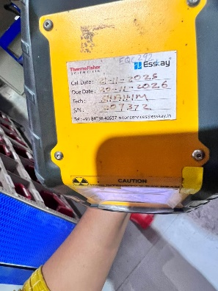 | 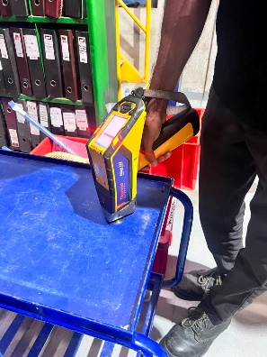 | 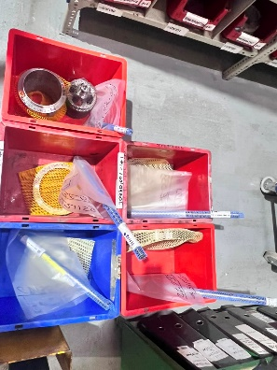
1. PMI Machine Details | 2. Calibration | 3. Components
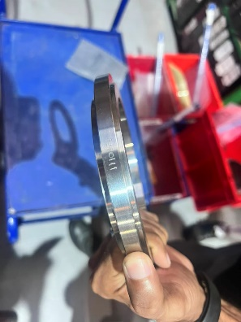 | 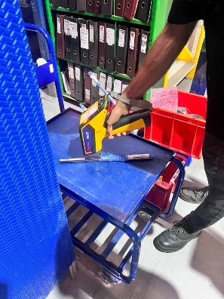 | 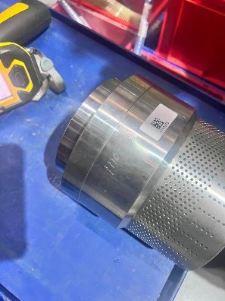
4. Seat Ring | 5. Stem | 6. Cage
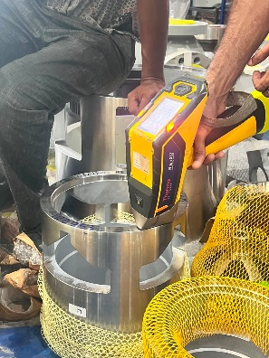 | 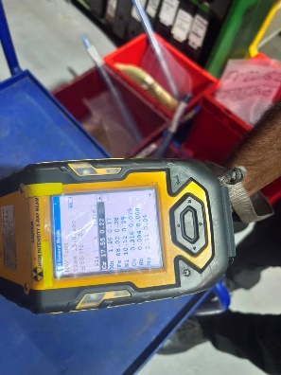 | 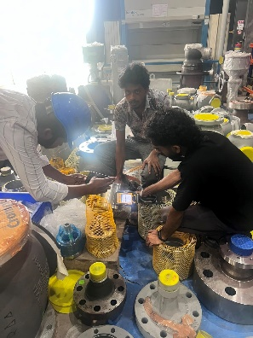
7. Cage | 8. Readings | 9. Readings
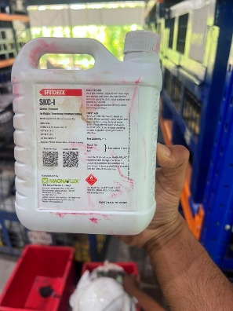 | 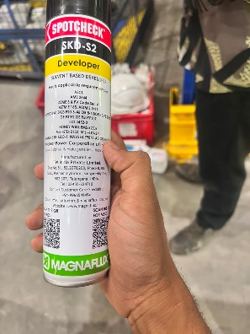 | 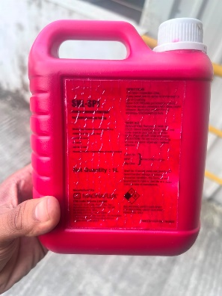
10. Check | 11.Check | 12.Check
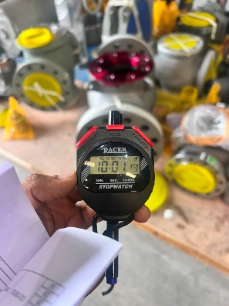 | 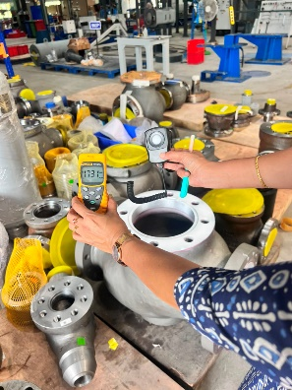 | 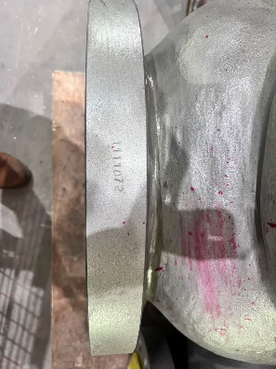
Stop Watch | Lux meter Reading | Tag No
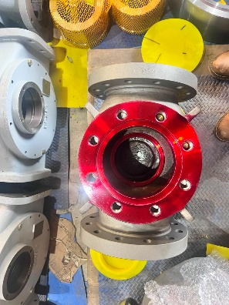 | 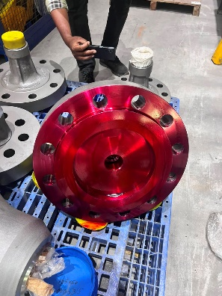 | 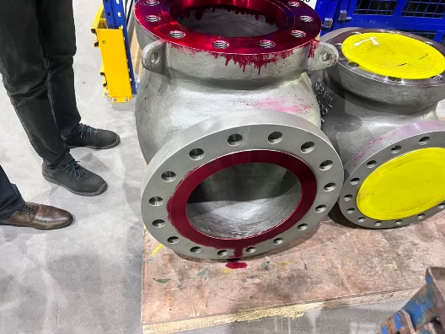
Penetrant Application | Penetrant Application | Penetrant Application
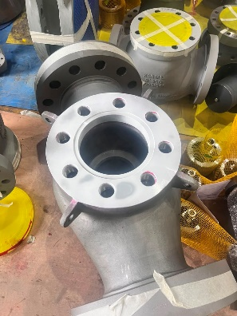 | 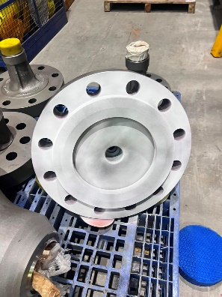 | 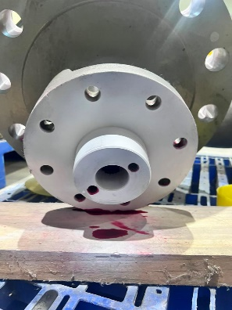
Developer Application | Developer Application | Developer Application
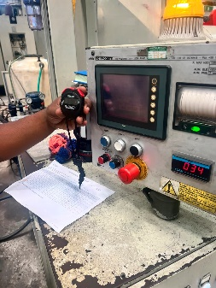 | 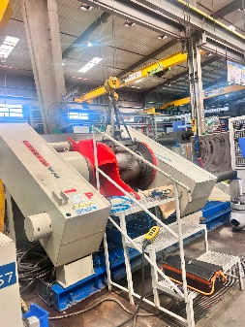 | 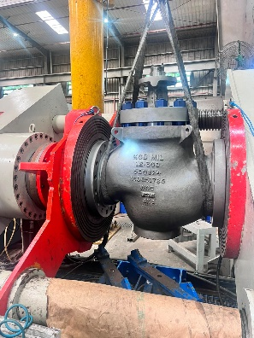
Pressure Test Reading | Pressure Test Setup | Pressure Test Setup
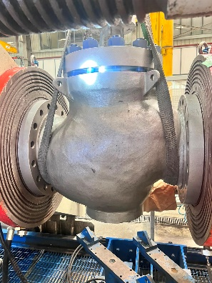 | 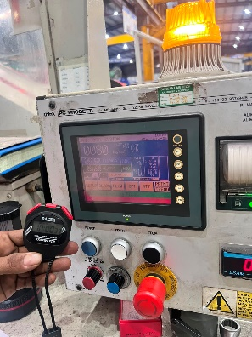 | 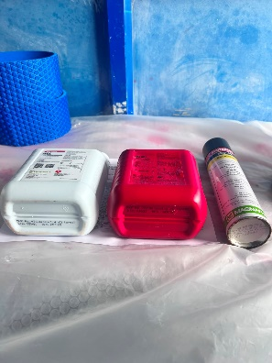
Pressure Test Setup | Pressure Test Setup | DPT Setup
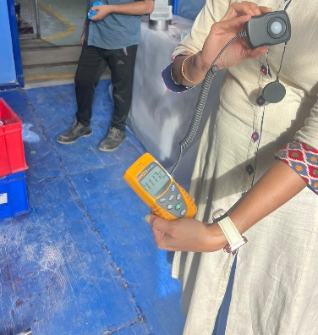 |  | 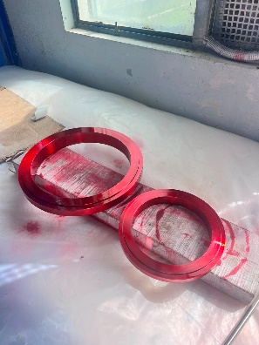
Lux meter reading | Penetrant Application | Penetrant Application
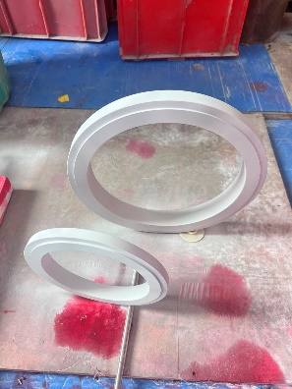 | 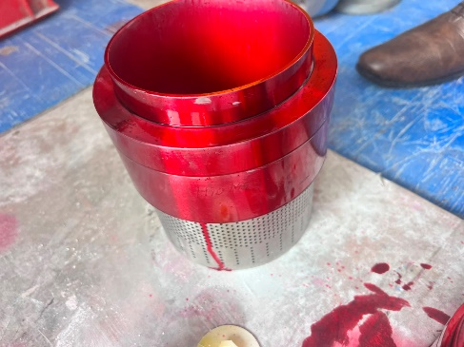 | 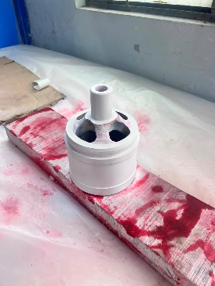
Developer Application | Penetrant Application | Developer Application
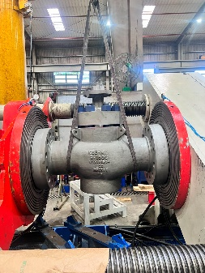 | 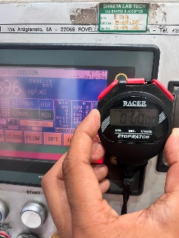 | 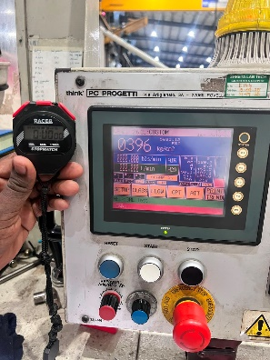
Pressure Test Setup | Pressure Test start | Reading
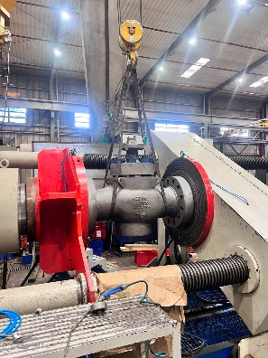 | 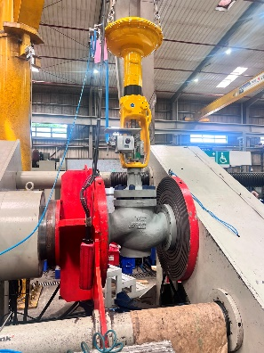 | 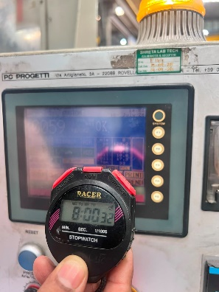
Pressure Test Setup | Pressure Test Setup | Pressure Test end
 | 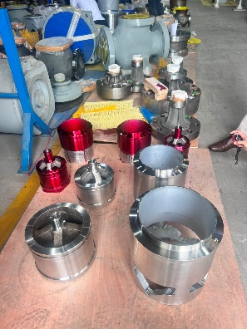 | 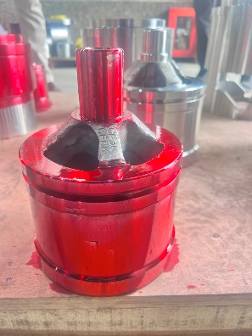
DPT Setup | Penetrant Application | Penetrant Application
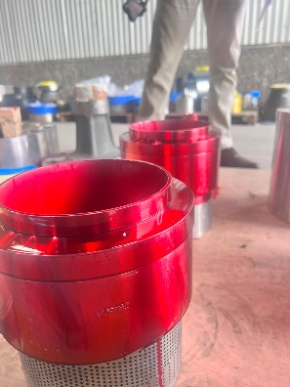 | 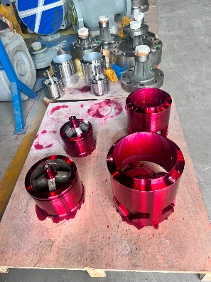 | 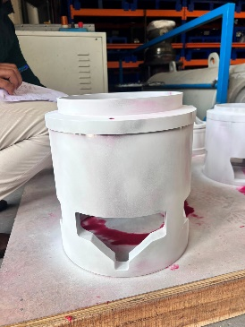
Penetrant Application | Penetrant Application | Developer Application
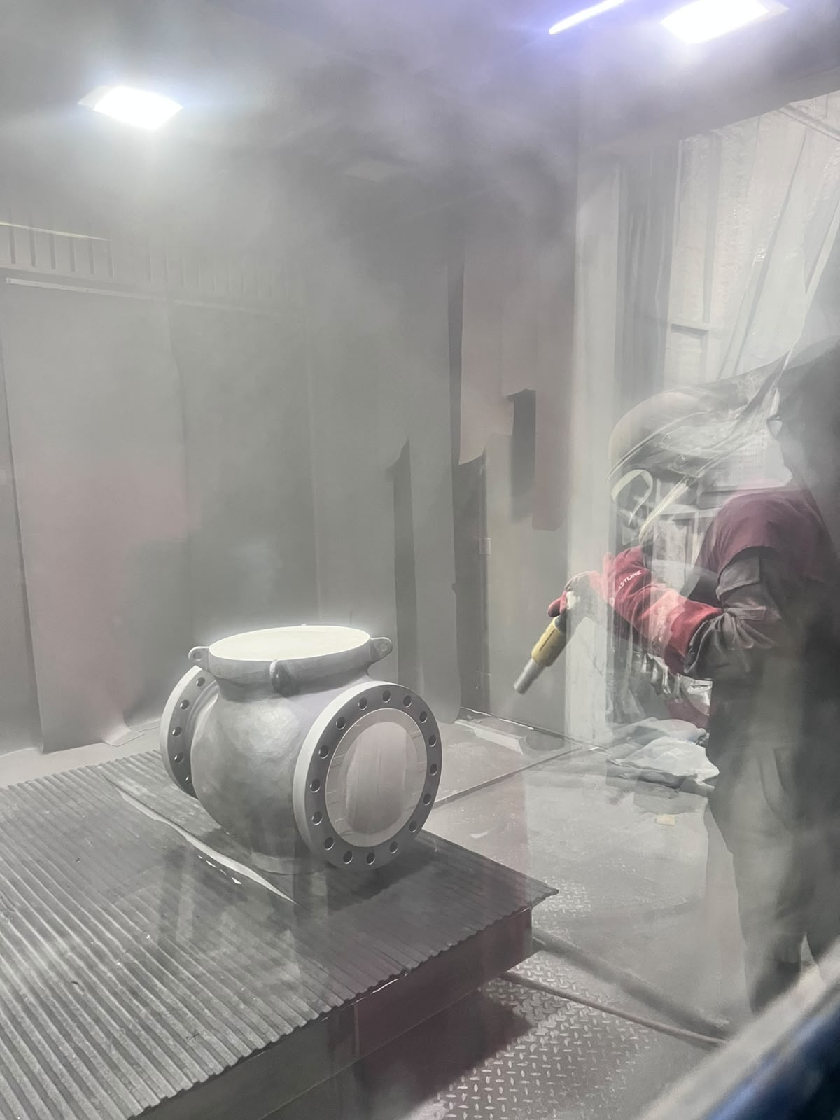 | 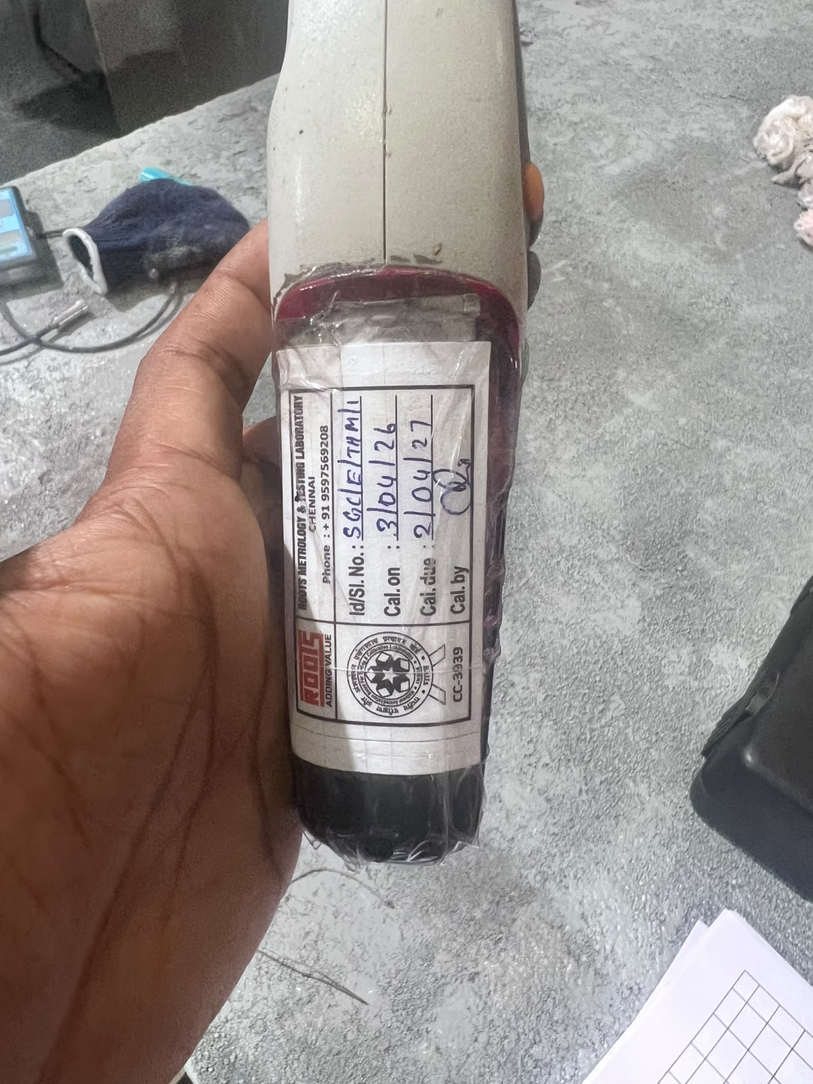 | 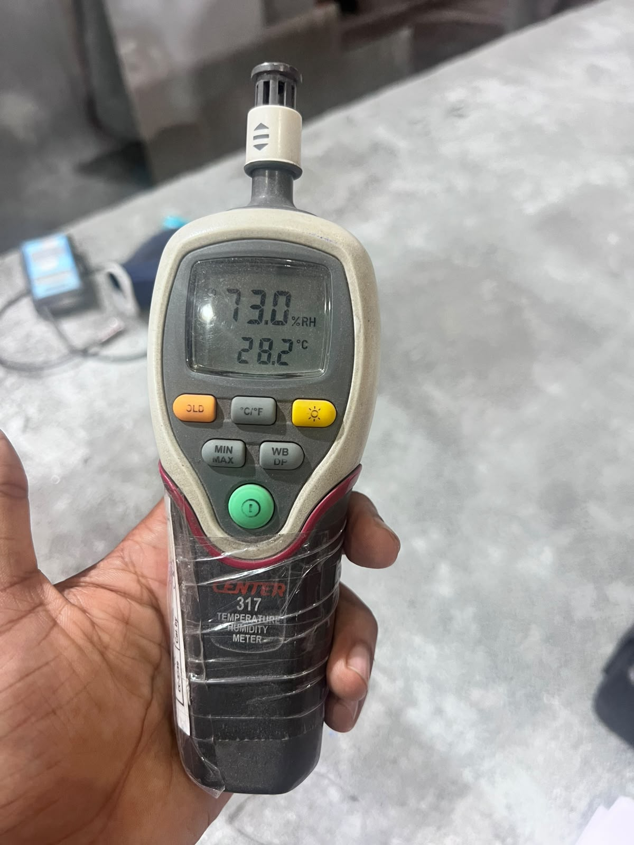
Blasting |  | Temp and Humidity check
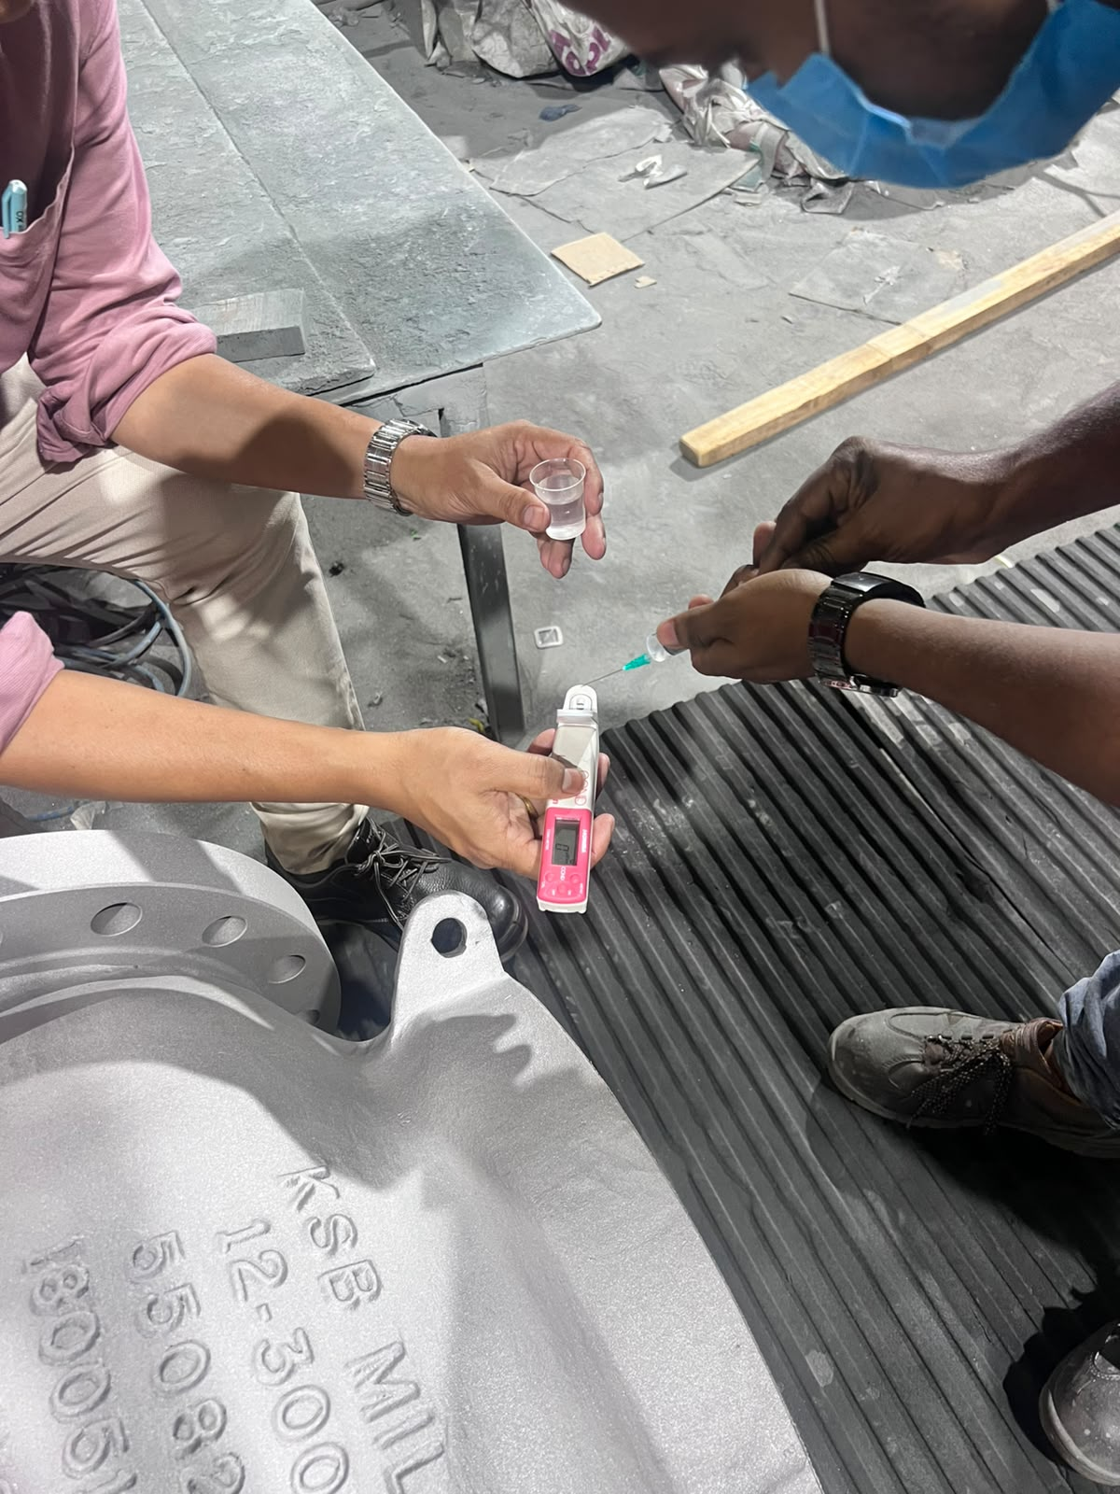 | 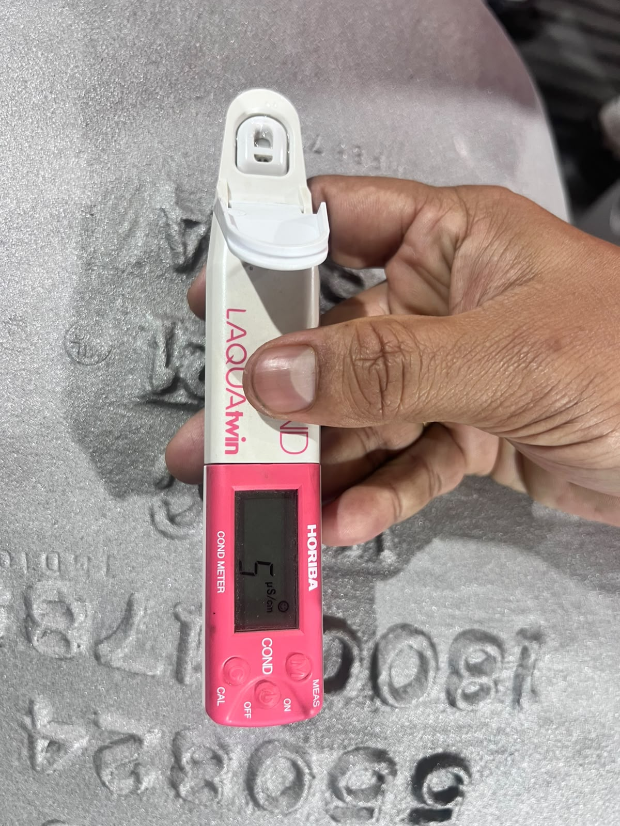 | 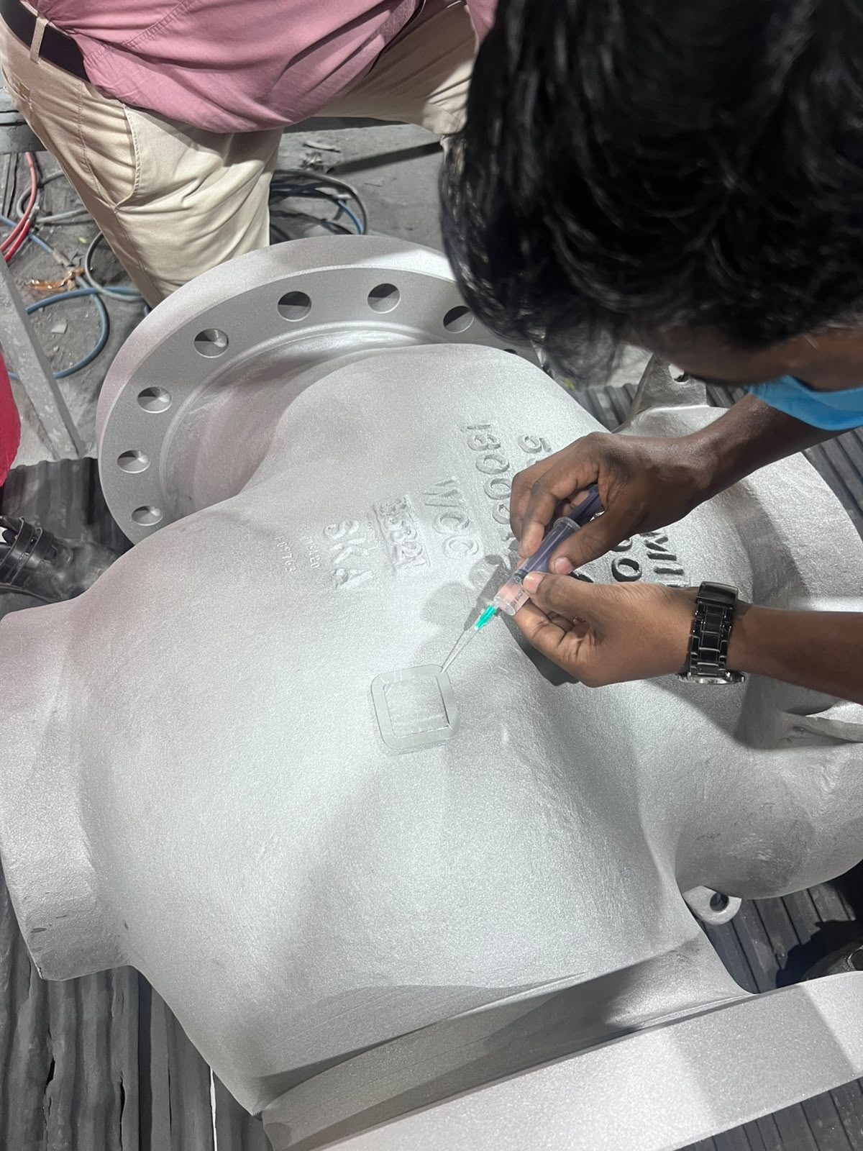
Reading-Salt test | Reading-Salt test | Reading-Salt test
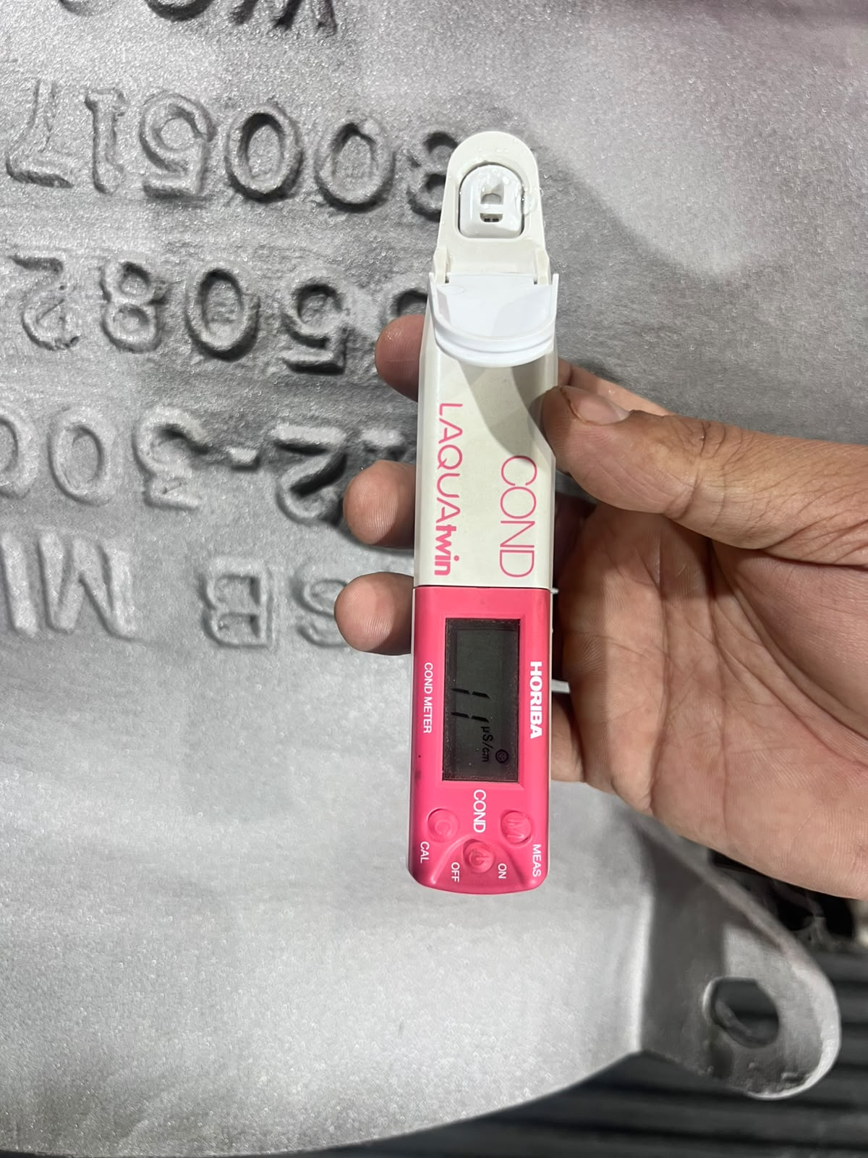 | 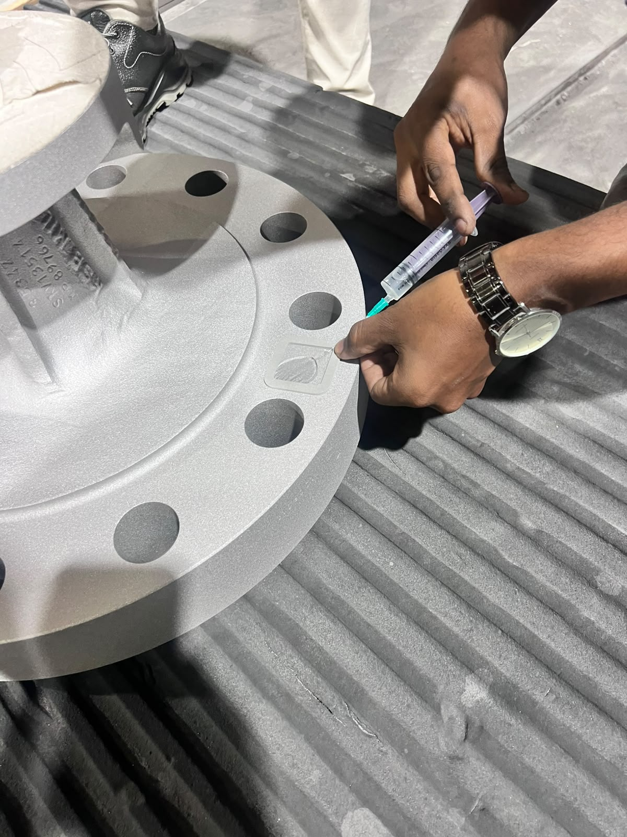 | 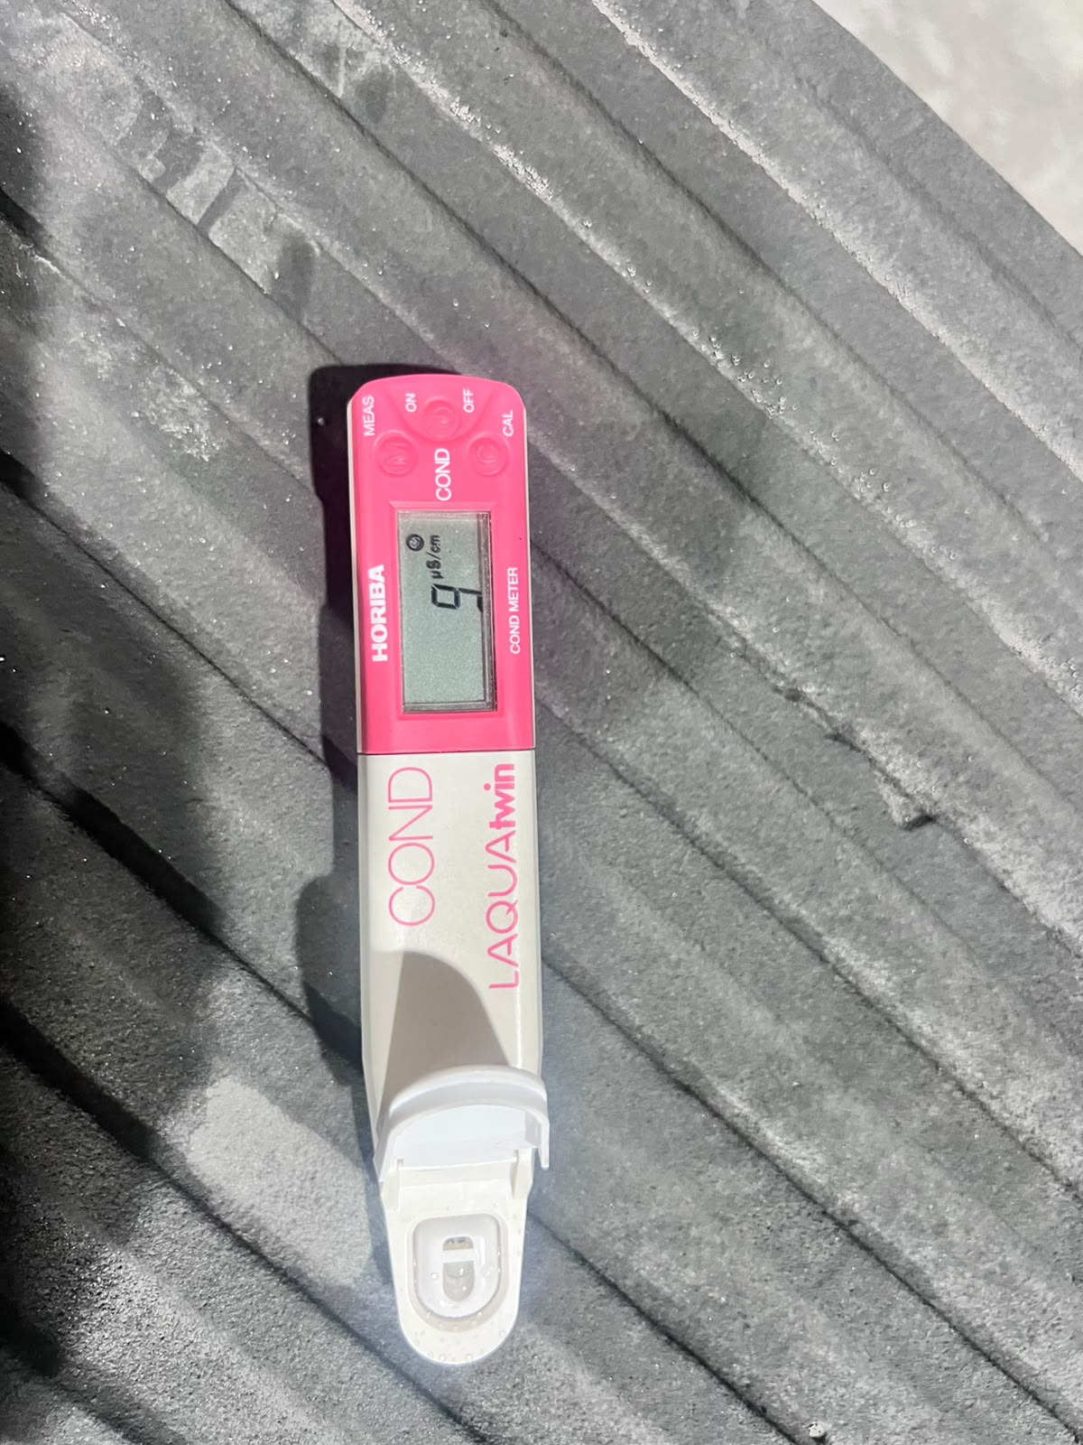
Reading-Salt test | Reading-Salt test | Reading-Salt test
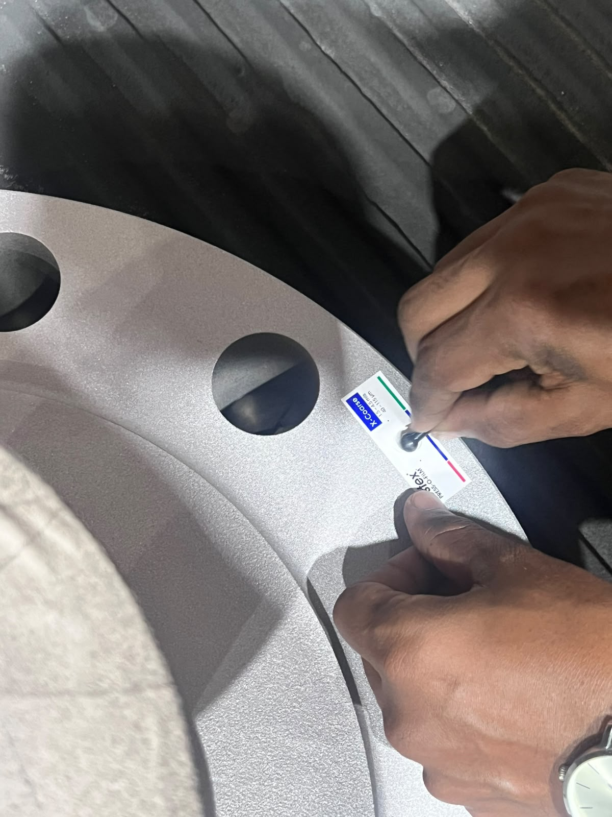 | 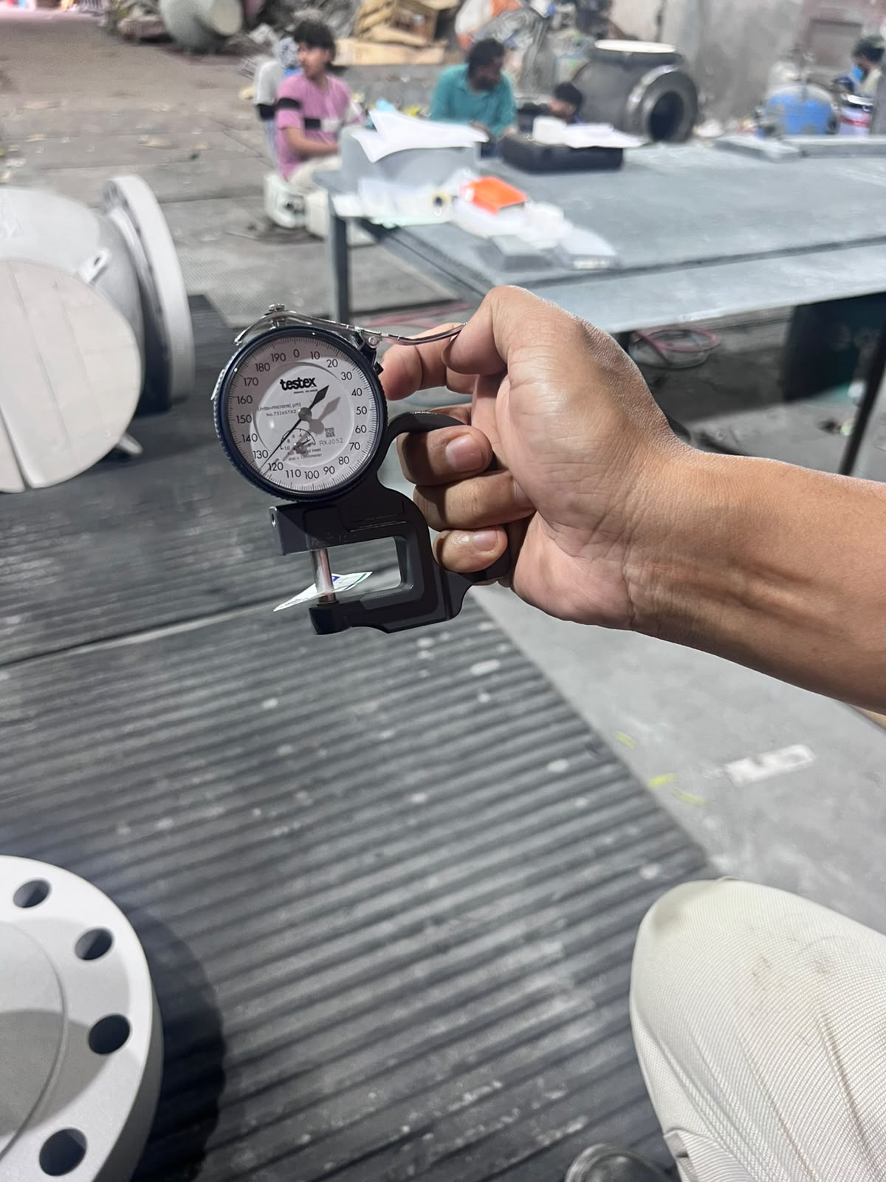 | 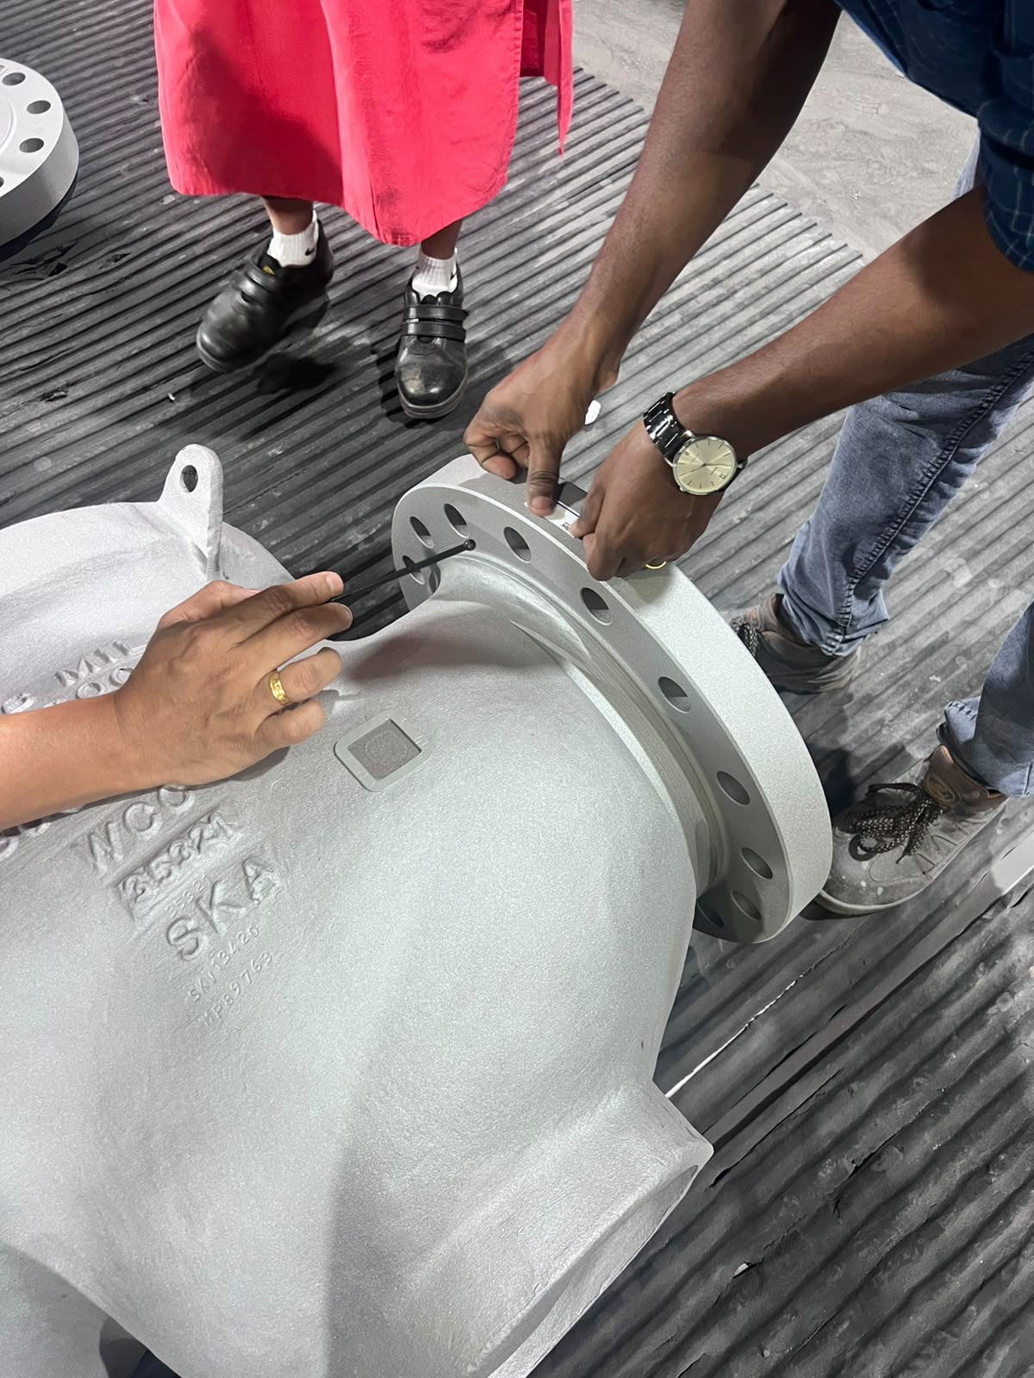
Profile Check | Profile Check | Profile Check
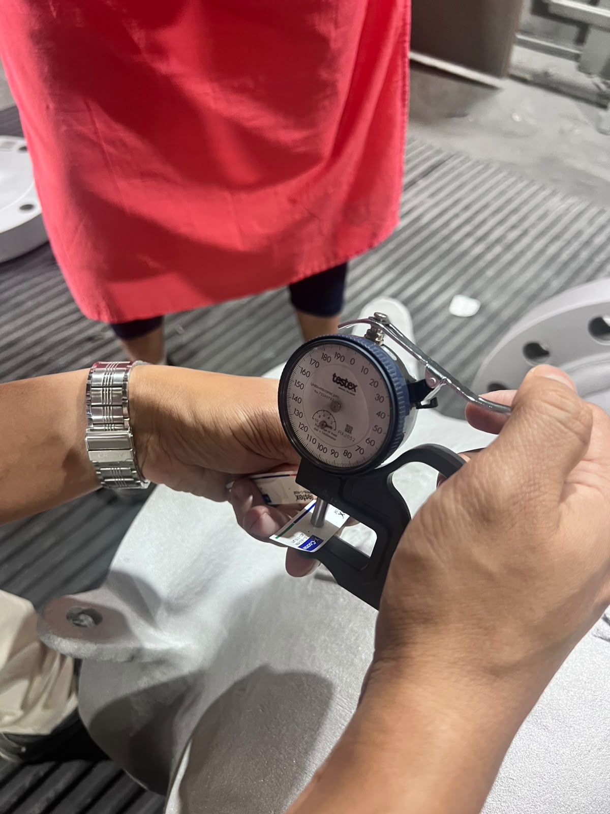 | 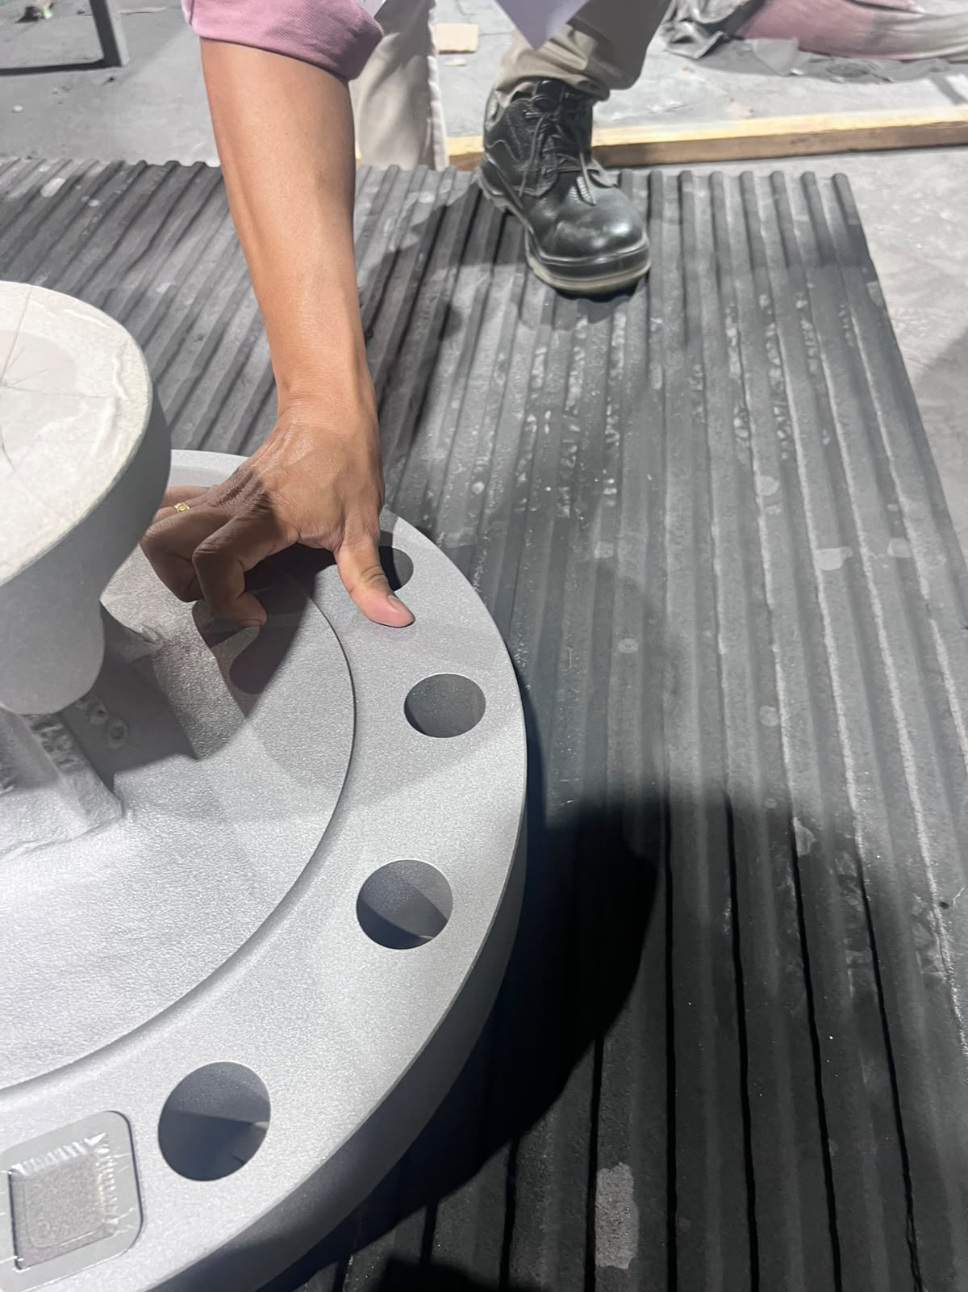 | 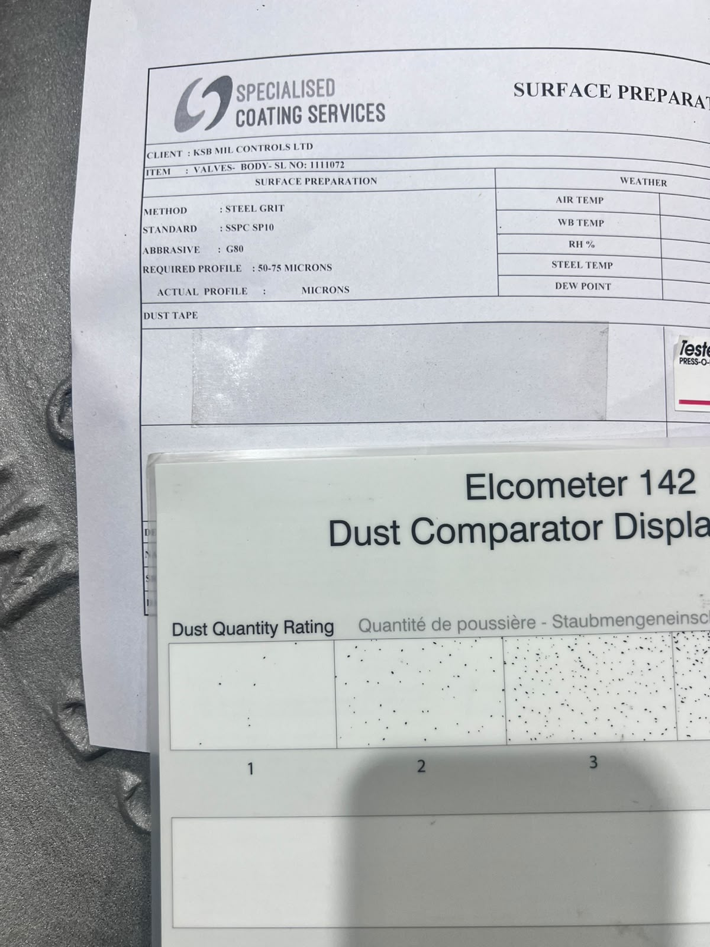
Profile Check | Dust Check | Dust Check
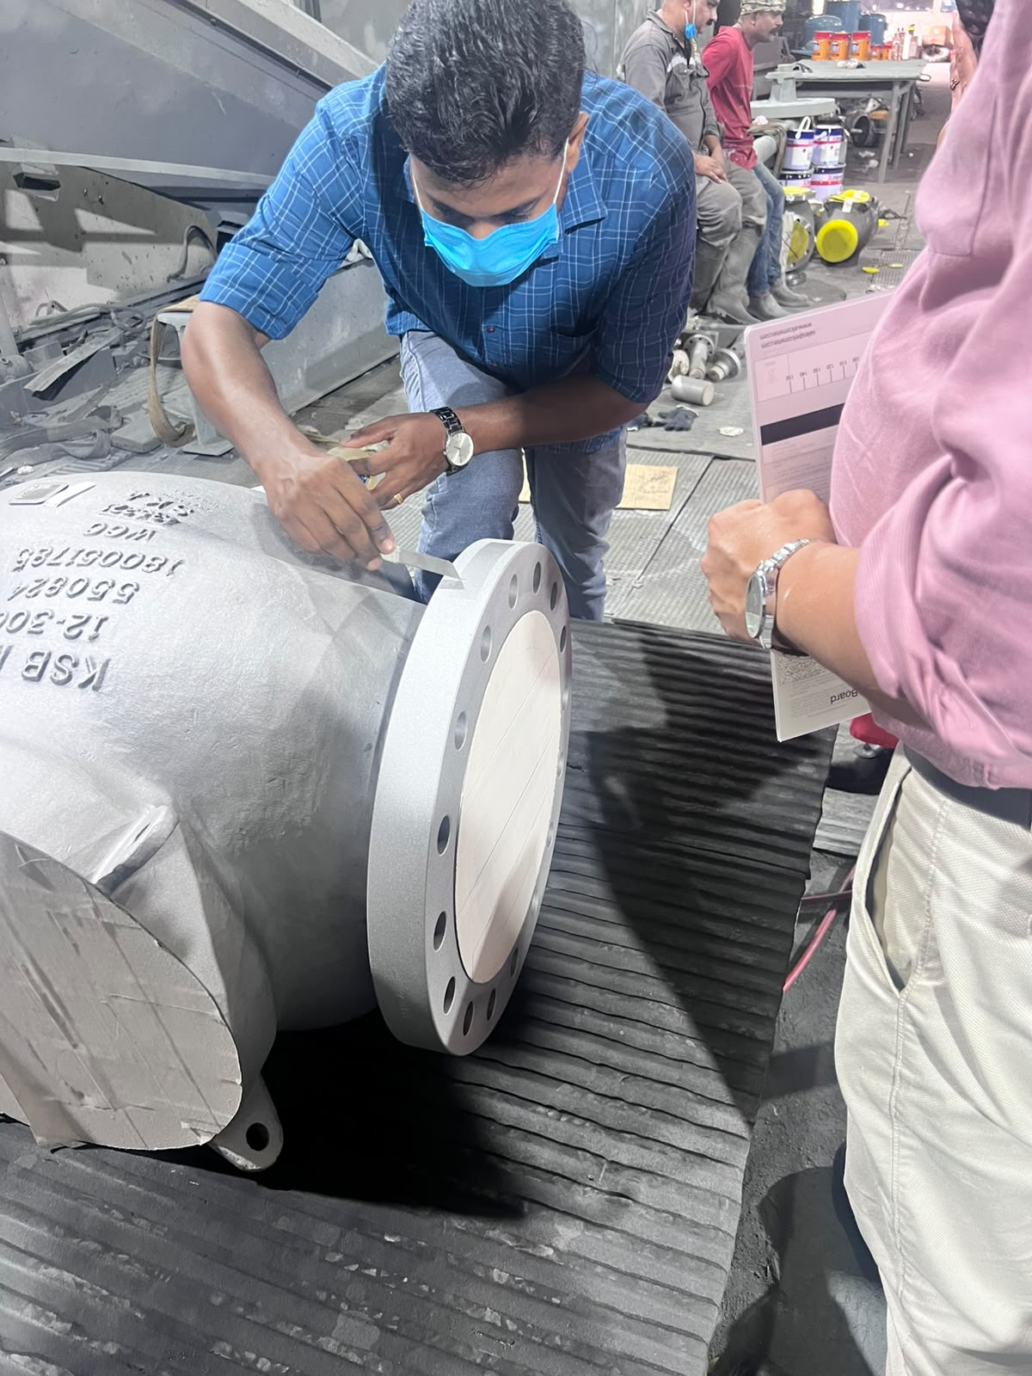 | 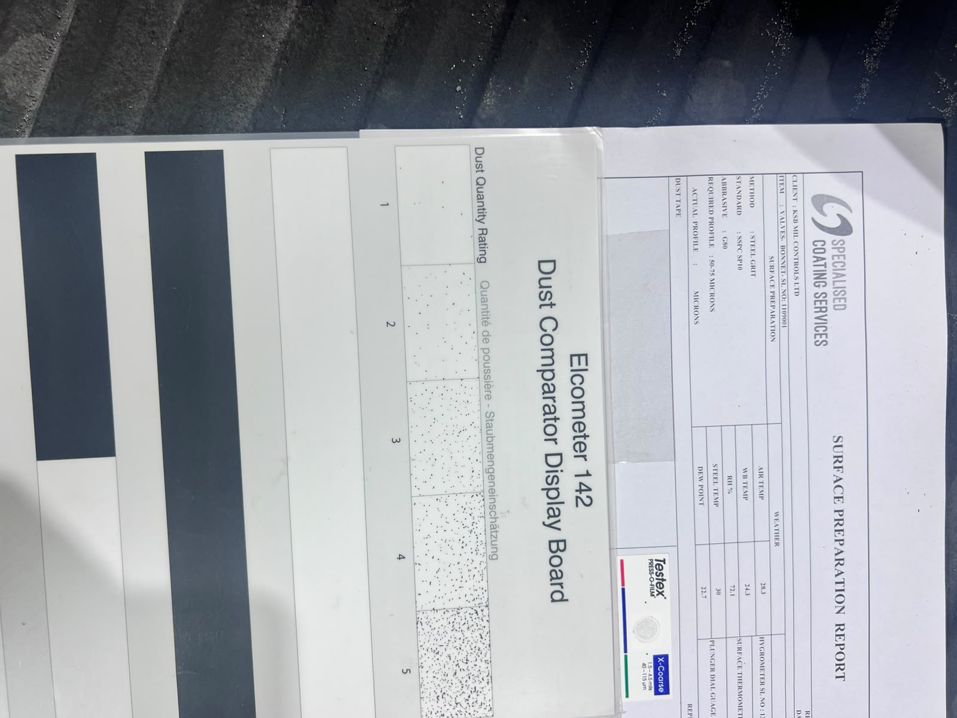 | 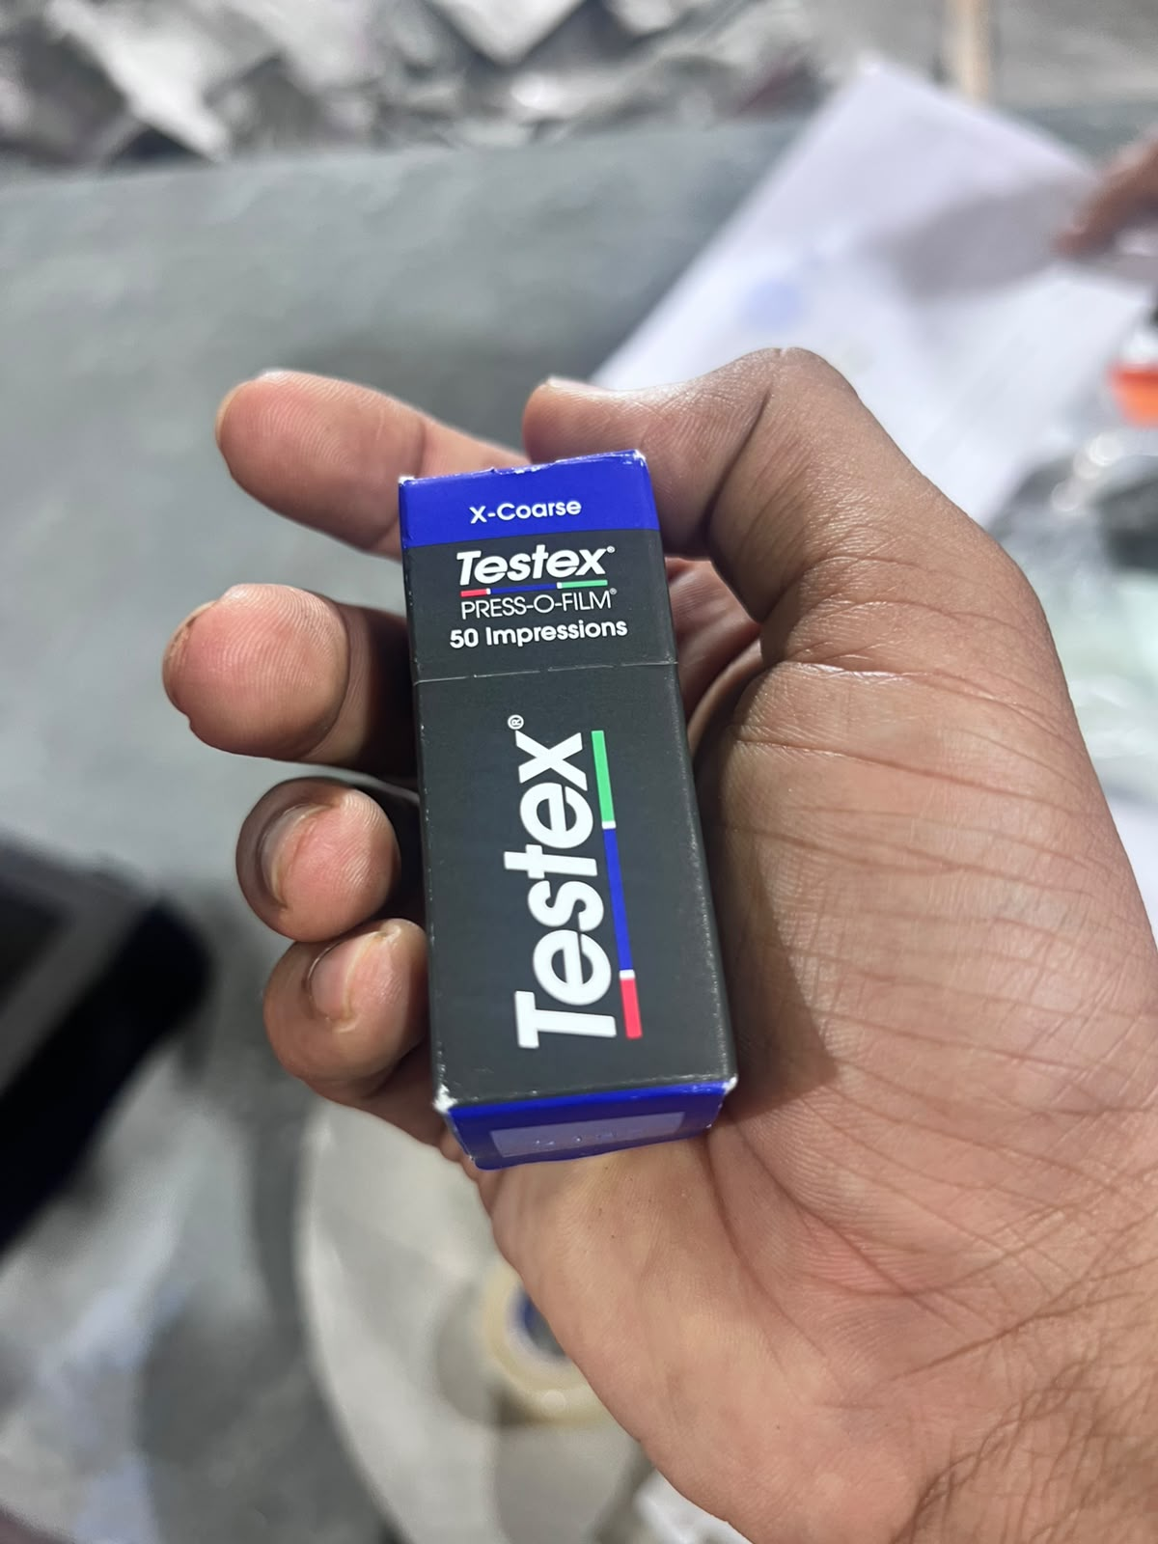
Dust Check | Dust Check
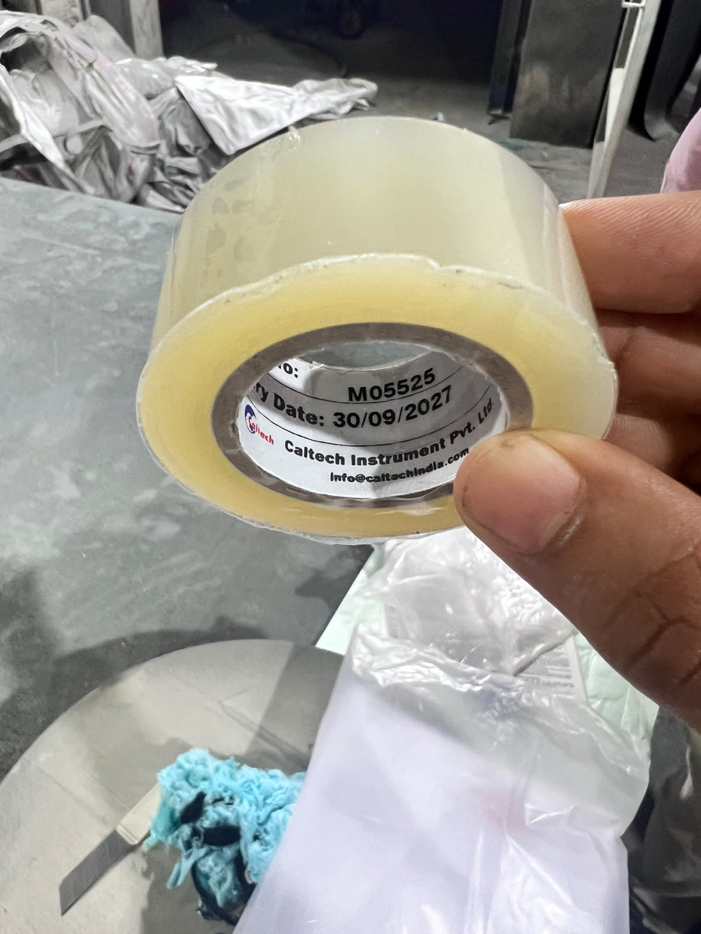

Section (G)
Punch List IPL, NCRs, Status & Observations OBS
Punch List IPL issued this visit ► |  |  |  | Yes |  |  |  | No |  |  | N/A
Punch List Document IPL Number/Title issued this visit ►
NON-CONFORMANCE / OBSERVATION REPORTS ISSUED BY KTI INSPECTOR |  |  |  |  |  |  | QUANTITY |  |  | EXPECTED DATE FOR COMPLETION
NCR issued during this visit ►
Total number of NCRs issued since the beginning of this visit ►
NCR still outstanding ►
OBS issued during the visit ►
Total number of OBS issued since the beginning ►
NOTE:: Any NCR shall be issued on the same day after inspection completion and shall be attached to this report.
HSE FEEDBACK ON VENDOR PERMISES
Safety Induction Provided ► |  | PPE Worn by All Personnel ► |  |  |  | Competency ►
Safety Procedures Available ► |  | Cleanliness/Tidiness ► |  |  |  | Trip Hazards ►
Inspection Release Note IRN issued during this RFI period |  |  | YES► |  |  |  |  |  | NO►

Section (H)
List of Inspection Associated & Supporting Attachments
- ATTACHMENT OF INSPECTION REPORTS TO THIS IR:
NCR ► |  |  | Partial PO IRN ► |  |  |  | Signed off RFI ►
Punchlist IPL ► |  |  | Balance PO IRN ► |  |  |  | Signed off ITP ►
Signed off Timesheet TS ► |  |  | Full PO IRN ► |  |  |  | Quality Documents ►
- ATTACHMENTS details TO THIS IR:
Sr. № | Document Description |  |  | Attachment(s) and ID No(s) |  |  |  | Total No. of Pages
1 | INSPECTION REPORT IR |  |  | DOC01 | xxx
2 | TIMESHEET TS |  |  | DOC02
3 | SIGNED OFF RFI |  |  | ATT01
4 | SIGNED OFF ITP |  |  | ATT02
5 | UNPRICED PO EPC to Vendor |  |  | ATT03
6 | IRN
… | NCR
… | IPL
… | TEST REPORTS
 | MTC CERTS
 | CALIBRATION CERTS |  |  | ATT04
 | …..
TOTAL NUMBER OF ALL SUBMITTED DOCUMENTS PAGES |  |  |  |  |  |  |  | ??
TOTAL NO. OF INSPECTIONS REPORTS & ATTACHMENTS |  |  |  |  |  |  |  | ??

The goods/items specified have been inspected in accordance with the scope of inspection provided. The result(s) is as stated on this inspection report IR Section-E.
INSPECTION CONCLUSION
Xxx

KTI iNSPECTOR |  |  | KTI Division Manager
  Name | Mr.Jithin KB |  | Name | Mr. Hany Elmantawy
Signature/Stamp |  |  | Signature/Stamp
Date | 17/07/2026 |  | Date | DD/MM/YYYY

++++END OF THE REPORT++++

